Student Assessment Submission and Declaration
When submitting evidence for assessment, each student must sign a declaration confirming that the work is their own.
Student name: Adel Shurab/21023153 |  | Assessor name: Mohammed Eshtay
Issue date (1St Submission):1/1/2023 | Submission date (1St Submission):18/1/2023 |  | Submitted on:
In case of resubmission
Issue date (1St Submission): | Submission date (1St Submission): |  | Submitted on:
Programme: Higher National Diploma in computing
Assignment number and title: Forecasting the future and optimization

Task 1

What is predictive analysis ?

It is one of the most important applications of data science. It aims to predict the future using historical and current data. In addition to data, statistical methods, data mining techniques, and machine learning are used to prepare predictions about future or unknown events. In business, predictive models exploit patterns in historical and transactional data to identify risks and opportunities

Today's companies and organizations dive into the data they get from their databases, images, video, sensors, or other data sources, to get insights from this data and to discover risks or opportunities Data scientists use deep learning and machine learning algorithms to find Patterns and prediction of future events. (What is predictive analytics?, 2023)

Predictive analysis techniques:

Regression : another widely important tool for statistical and machine learning. The main objective of the tasks is based on the responses that appear, showing immediate data or regression. The output will depend on what the model has learned in the training phase. Essentially, regression models use input data (dependent variables) and output variables) a specific association between the corresponding input and output or their corresponding numerical output values (the dependent variables). (ProjectPro, 2023)

For example, companies use the forecast to predict future sales through old data and advertisements

Linear Regression: Linear regression is an algorithm that provides a linear relationship between an independent variable and a dependent variable to predict the outcome of future events.

benefits of linear regression
1. Easy implementation
2. Interpretability
3. Scalability
4. Optimal for online settings
Example: if an individual was 70 inches tall, we would predict his weight to be: Weight = 80 + 2 x (70) = 220 lbs. In this simple linear regression, we are examining the impact of one independent variable on the outcome

Multiple Linear Regression:

is a statistical technique that uses several explanatory variables to predict the outcome of a response variable. It is also an extension of linear regression (OLS) that uses only one explanatory variable.

MLR is also widely used in econometrics and financial references.

Example: Prediction of CO2 emission based on engine size and number of cylinders in a car.

Forecasting:

Is a technique that uses historical data as input to make informed estimates that are predictive in determining the direction of future trends.

Forecasting involves making predictions about the future.

In finance, forecasting is used by companies to estimate profits or other data for subsequent periods.

Traders and analysts use forecasts in valuation models, in time trades, and to identify trends.

Forecasts are often based on historical data.

Because the future is uncertain, forecasts must be revised often, and actual results can vary greatly.

Moving average is a time series forecasting method that is used to smooth out short-term fluctuations in data and identify longer-term trends. The method involves calculating the average of a set of consecutive data points over a specified period of time, known as the moving window. This average is then used as the forecast for the next period.

There are two main types of moving average: simple moving average and weighted moving average.

Simple moving average (SMA): This method involves averaging all of the data points within a fixed window. The forecast for the next period is simply the average of the previous "n" periods.

For example, if the window size is 3, the forecast for the next period would be the average of the current period and the previous 2 periods.

Weighted moving average (WMA): This method assigns different weights to each data point within the window, with more recent data points typically given more weight. The forecast for the next period is the weighted average of the previous "n" periods.

For example, if the window size is 3, and the weights are 0.3, 0.2, 0.1 for the most recent, second most recent and third most recent data points respectively

exponential smoothing, the forecast for the next period is calculated by adding the current prediction error to the previous forecast. The prediction error is the difference between the actual value and the previous forecast. The weight given to the prediction error and previous forecast is determined by a smoothing constant, usually represented by the symbol alpha (α). The value of alpha is between 0 and 1, with a higher value indicating that more weight is given to recent observations.

There are several variations of exponential smoothing, each with a different level of complexity and suitability for different types of time series data.

Simple exponential smoothing: This method only uses one smoothing constant, alpha, to adjust the weight given to past observations. It is best suited for forecasting time series with no trend or seasonality.

Holt's linear exponential smoothing: This method uses two smoothing constants, alpha and beta, to adjust the weight given to past observations and the trend component, respectively. It is best suited for forecasting time series with a linear trend.

Holt-Winters exponential smoothing: This method uses three smoothing constants, alpha, beta and gamma, to adjust the weight given to past observations, the trend component and the seasonal component, respectively. It is best suited for forecasting time series with both trend and seasonality.

Examples :

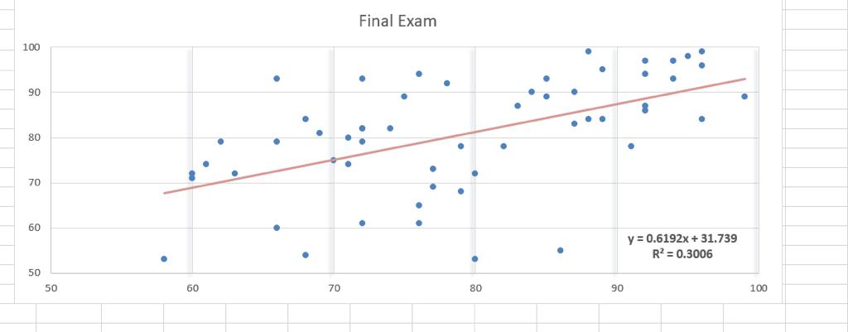

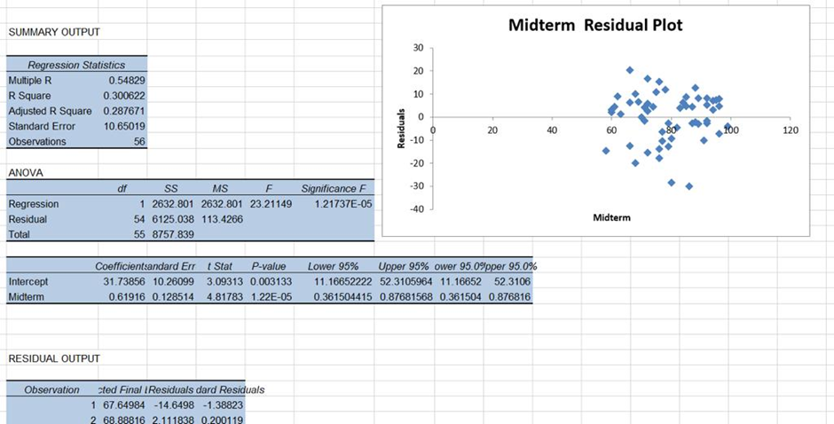

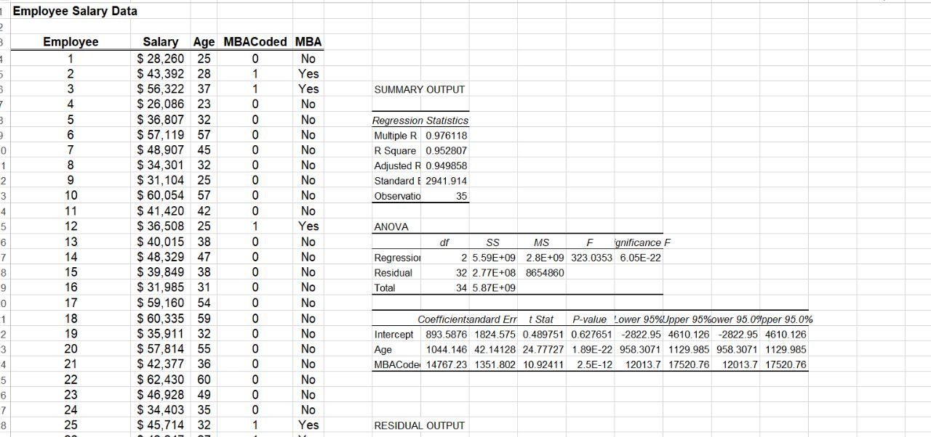

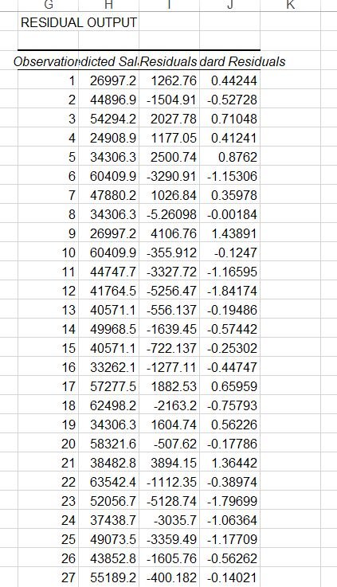

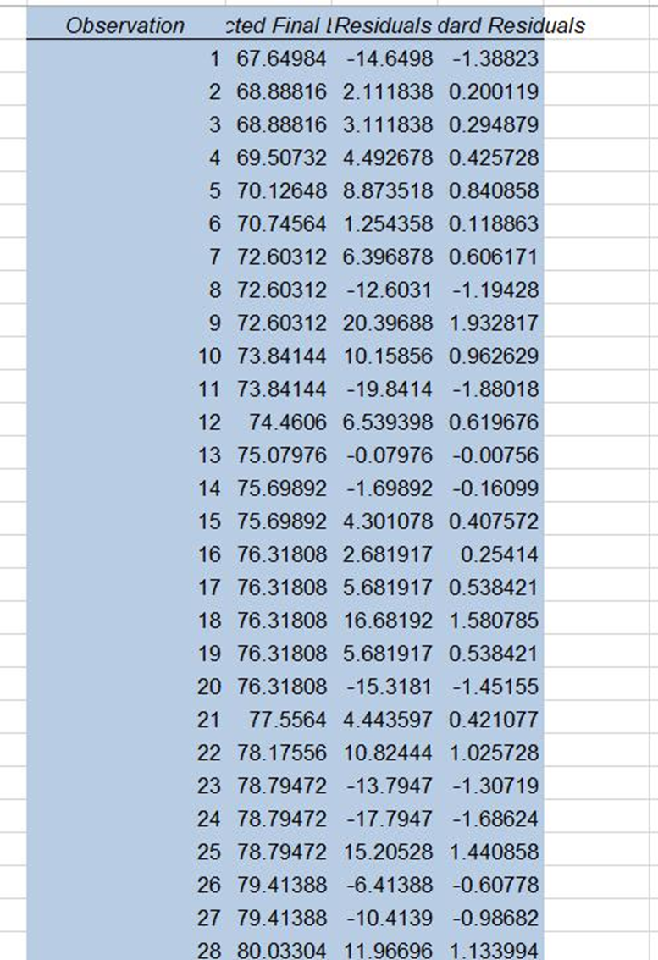

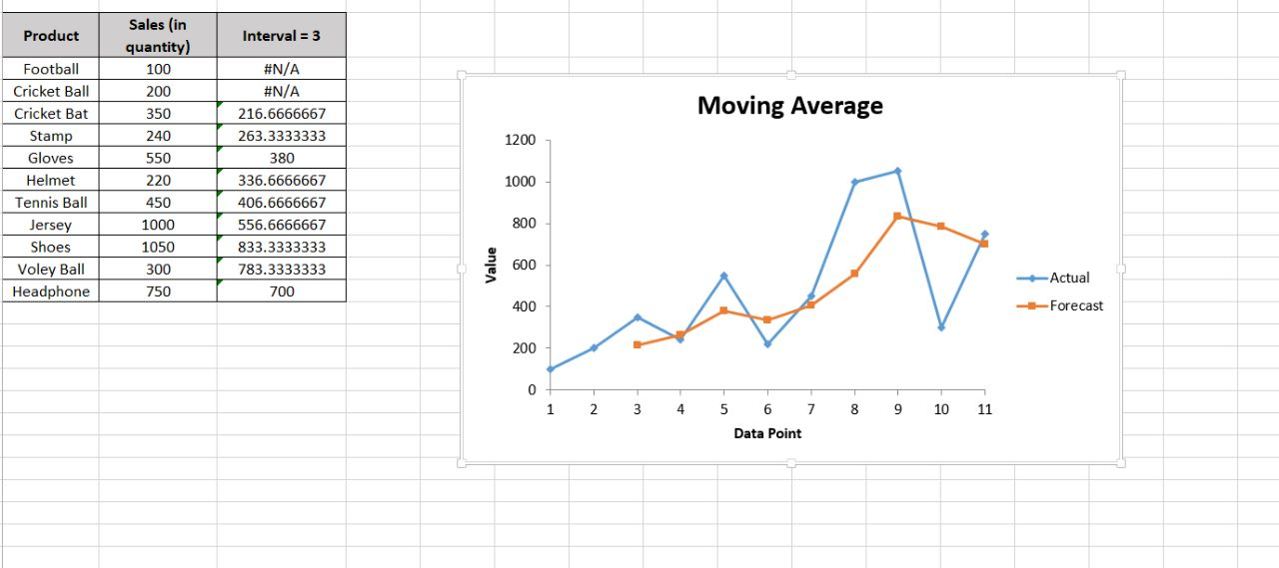

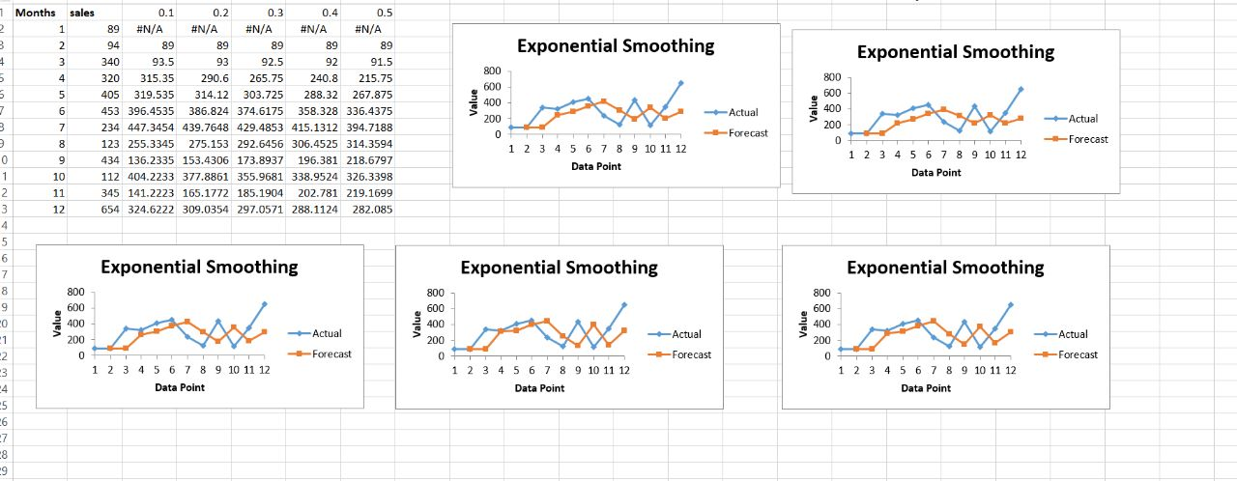

Comparison between linear regression and multiple regression: (GeeksforGeeks, 2020)

Linear regression
Advantages | Disadvantages
Linear regression is easy to implement and easier to interpret the output coefficients | Outliers in the linear regression technique can have dramatic effects on the slope and linearity limits in this technique.
The relationship between the independent variable and the dependent variable is linear, so this algorithm is the best to use because it is not complicated compared to other algorithms. | Variously, linear regression assumes a linear relationship between the dependent and independent variables. This means that it assumes a straight line relationship between them. It assumes independence between traits.
Overfitting can be avoided by using some dimension reduction techniques, regularization techniques (L1 and L2), and cross-validation | Linear regression also looks at the relationship between the mean of the dependent variables and the independent variables. Just as the mean is not a complete description of a single variable, linear regression is not a complete description of the relationships between variables.

Multiple linear regression
Advantages | Disadvantages
It can handle multiple independent variables, which helps to identify which variables have a significant impact on the dependent variable. | MLR assumes linearity, independence of errors and normality of errors. Violation of these assumptions can lead to biased or incorrect predictions.
It can handle non-linear relationships between variables by transforming the data. | It can become unreliable when there are too many independent variables, known as the curse of dimensionality.
It is a widely used technique and is easy to interpret the results. | MLR can be sensitive to outliers, which can have a large impact on the results.

The main difference between the two is the number of independent variables. Linear regression models the relationship between a single independent variable and a dependent variable, while multiple regression models the relationship between multiple independent variables and a dependent variable

In summary, Linear regression is used when you have one independent variable and multiple regression is used when you have more than one independent variable.

When evaluating how these methods can be used for forecasting, it is important to consider the strengths and weaknesses of each technique and how it applies to the specific problem at hand. It is also important to consider alternative technologies and whether they are more appropriate to the problem. In addition, it is important to consider relevant information such as the type of data used and the forecasting goals.

Linear regression is a statistical technique that is used to model the relationship between a single independent variable and a dependent variable. It is commonly used for forecasting, as it is a simple and straightforward technique.

Strengths: It is a widely used technique, and there is a lot of statistical software available to perform linear regression analysis.
Weaknesses: Linear regression is limited to a single independent variable, which can be a limitation when there are multiple factors that affect the outcome.
Alternative actions: Time series analysis: When the data is time-based, time series analysis techniques and prophet can be used for forecasting.
Relevant information: The level of accuracy required for the forecast.

Multiple linear regression (MLR) is a statistical technique that is used to model the relationship between multiple independent variables and a single dependent variable. It is commonly used for forecasting, as it can handle multiple factors that affect the outcome.
Strengths: It can handle non-linear relationships between variables by transforming the data.
Weaknesses: It can become unreliable when there are too many independent variables, known as the curse of dimensionality.
Alternative actions: Stepwise or backward selection : When the number of independent variables is large, stepwise or backward selection methods can be used to select the most important variables for the model.
Relevant information: The nature of the problem and the relationships between variables.

Task 2:

examine prescriptive analytic techniques:

Perspective analysis: a thorough investigation of a person's outlook or point of view on a particular subject. Students learn how the subject is interconnected and start to consider the data from several angles. Either an individual or a small group can complete this task.

Techniques used in perspective analysis:

Optimization: are used to choose which measure to maximize or minimize in order to identify the best solution to a problem. Numerous issues can be resolved using optimization algorithms, such as figuring out the best way to distribute resources or finding the shortest route between two sites.

1-Liner Optimization:

is a method for achieving the greatest possible outcome (such as highest profit or lowest cost) in a mathematical model with needs represented by linear connections.

Example: Solve the following linear programming problem using the graphical method. Solution: Using the constraints we get the equations of the lines as 4x + y = 40 and 2x + 3y = 90. As the minimum value of Z is 127, thus, B (3, 28) gives the optimal solution.

2-Interger Linear Optimization:

an optimization problem in which the variables are integer values, and the objective function and equations are linear .All variables must be full numbers, a special sort of integer problem has variables that can only be 0 or 1.

Example of an ILO problem is a company that needs to decide how many products to produce and how many workers to hire in order to maximize its profit. Let's say that the company can produce two different products, A and B, and each product has a different production cost and selling price. Also, the company wants to hire a certain number of workers.

The company wants to determine the optimal number of products A and B to produce and the number of workers to hire, in order to maximize its profit, subject to the following constraints:

The number of products A and B produced must be integers.

The number of workers hired must be an integer.

The production capacity of the company and the availability of workers must be taken into account.

3- Nonlinear optimization is a branch of mathematics and computational methods that deals with the problem of a local extremum of a nonlinear function or finding a minimum. It is used to find the best solution for a wide range of problems, including machine learning, control systems, and optimizing complex systems.

One way to use perspective techniques to find the best course of action for a particular event is to use a technique called scenario planning. Scenario planning involves creating different possible scenarios for an event and analyzing the possible outcomes of each scenario. This allows us to determine the best course of action based on the available data and information.

For example, let's say the ministry wants to analyze the potential impact of a new policy on the education system. We could create different scenarios based on different assumptions about the policy's implementation, such as the level of funding, the level of support from the government, and the level of resistance from the education system. We could then use data analysis techniques to analyze the potential outcomes of each scenario and identify the best course of action based on the data.

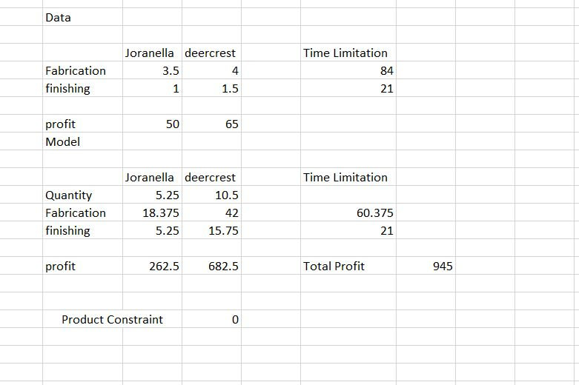
A nonlinear optimization model is a mathematical model that is used to find the optimal solution to a problem where the objective function or the constraints are nonlinear.
• The construction of nonlinear optimization models is based on basic modeling principles, such as business logic to determine appropriate functional relationships between decision variables or empirical data and line fitting techniques to characterize nonlinearity.

Sales = -2.95 * Price +3,241

TotalRevenue =Price× Sales

=Price(-2.95 xPrice +3,241)

=-2.95xPrice? +3.241xPrice

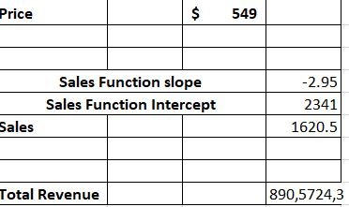

This is a summary of the Excel solution and an analysis of the data

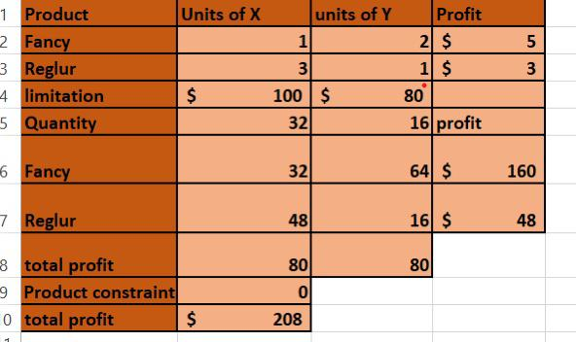

The first thing I determined was the quantitative unit of y, double the unit of x. I put them 10 and 5 and made a model and multiplied the fancier and the regular in the data by the quantity in order to make a model and get the profit and the total profit. It is equal to zero or greater than zero and you made it through the solver and the total profit is the result of multiplication

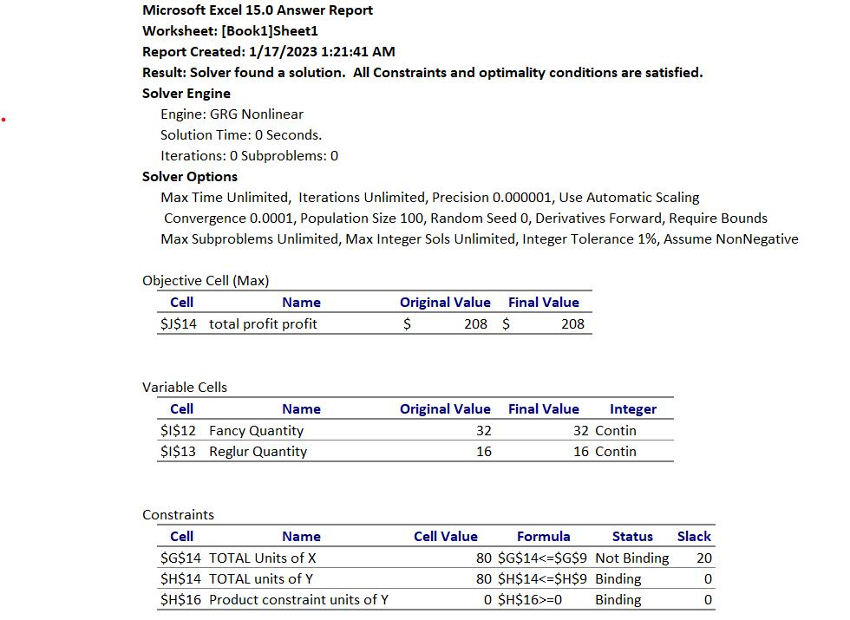

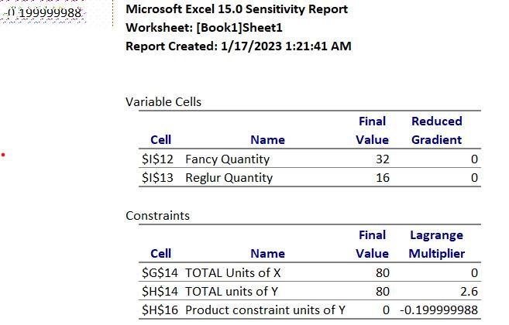

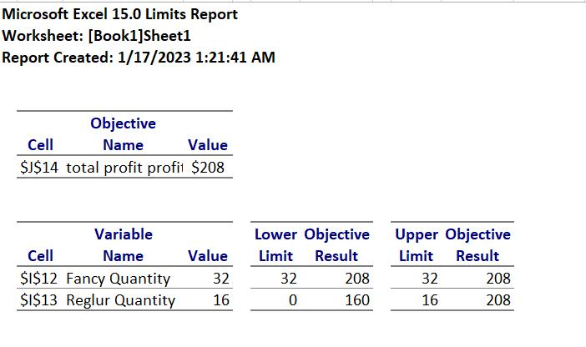

References

ProjectPro. (2023, jan 8). ProjectPro. Retrieved from ProjectPro: https://www.projectpro.io/article/predictive-modelling-techniques/598
What is predictive analytics? (2023, jan 8). Retrieved from IBM: https://www.ibm.com/topics/predictive-analytics

Plagiarism
Plagiarism is a particular form of cheating. Plagiarism must be avoided at all costs and students who break the rules, however innocently, may be penalised. It is your responsibility to ensure that you understand correct referencing practices. As a university level student, you are expected to use appropriate references throughout and keep carefully detailed notes of all your sources of materials for material you have used in your work, including any material downloaded from the Internet. Please consult the relevant unit lecturer or your course tutor if you need any further advice.
Student Declaration
Student declaration
I certify that the assignment submission is entirely my own work and I fully understand the consequences of plagiarism. I understand that making a false declaration is a form of malpractice.

Student signature: Date:

